Lightchain AI: Brand Narrative & Positioning
Prepared by Lunar Strategy for the Lightchain AI DUNA · Draft v1 · 9 October 2026
Status: for review with the Lightchain team. Website and brand changes go to the DUNA as suggestions.

1. Brand on a page
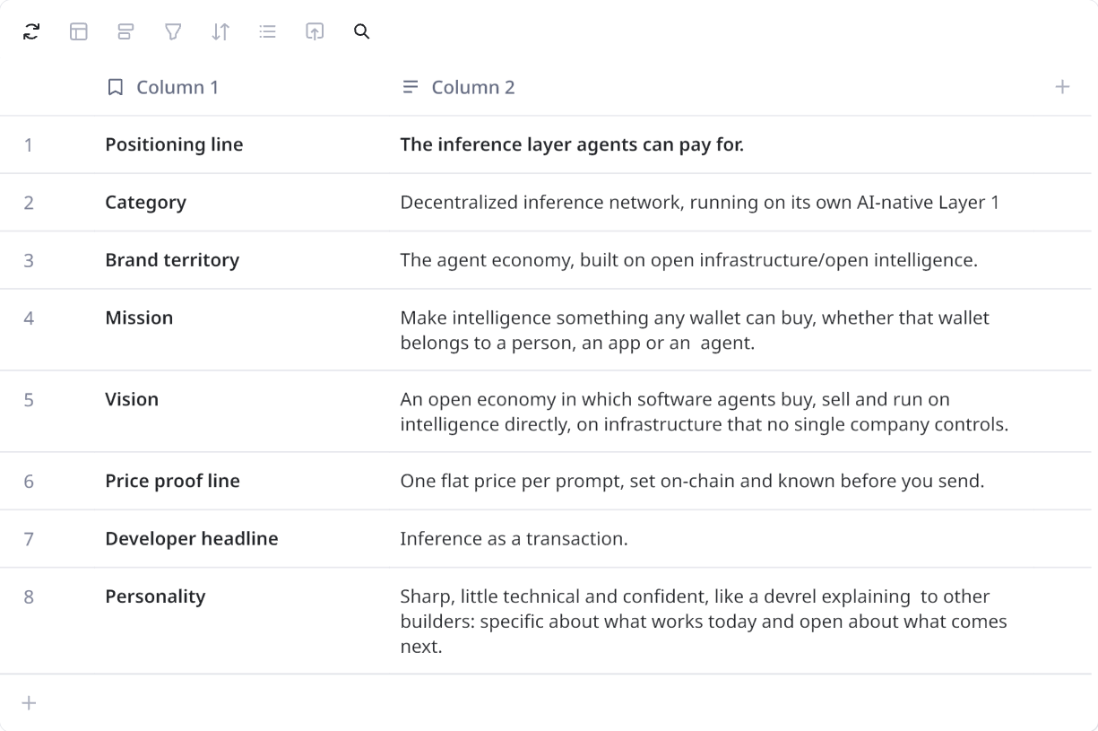

2. Brand narrative

Why now
AI is changing who the customer is.
For the last few years, the buyer of intelligence has been a person typing into a chat window or a company paying a monthly API bill. The next wave of demand looks different: software agents that trade, research, write code, monitor markets and run workflows around the clock, often calling a model thousands of times a day without a human in the loop.
Today's AI infrastructure was not designed for that buyer.
It assumes a person who can create an account, attach a credit card, rotate API keys and reconcile a usage-based invoice at the end of the month. An agent can do none of those things on its own. What it does have is a wallet, and what it needs is intelligence it can buy from that wallet, one call at a time, at a price it can plan around.

What Lightchain is
Lightchain is the inference layer built for that buyer. Open AI models for text, code, vision, voice and embeddings are served by a network of independent GPU workers. Every request is paid in LCAI and settled on Lightchain's own AI-native Layer 1, at a flat fee per prompt that is written into the chain and visible before the request is sent. An agent, an app or a person needs nothing more than a wallet to use it: there is no account to open, no key to manage and no invoice waiting at the end of the month.
Because pricing is per prompt rather than per token, a long answer costs the same as a short one, which matters most to the workloads agents generate, such as coding sessions, research tasks and document processing. Because the network is open, anyone with a capable GPU can join it as a worker and earn from the requests it serves, and the people who hold LCAI decide which models the network runs and what each one costs.

Where it goes
As agents take on more of the world's work, they will become some of the largest buyers of intelligence there are.
Lightchain's aim is to be the layer they run on: open models, open supply and open pricing, settled on a chain built for exactly this job. That future should not depend on a handful of companies deciding who gets access and on what terms, and Lightchain is built so that it doesn't have to.
The inference layer agents can pay for.

One-liners (by length)
- Short: The inference layer agents can pay for.
- Medium: Open AI models that any agent, app or person can call from a wallet, at one flat price per prompt.
- Long: Lightchain is an inference network on its own chain, where agents and apps call open AI models from a wallet at a flat price per prompt, served by independent GPU workers and governed by LCAI holders.

3. Mission, vision and values

Mission
Make intelligence something any wallet can buy, whether that wallet belongs to a person, an app or an agent.
Access to AI should not depend on having a credit card, a company account or a country on an approved list. If you, or your software, can hold a wallet, you should be able to access intelligence directly and at a fair, visible price.

Vision
An open economy in which software agents buy, sell and run on intelligence directly, on infrastructure that no single company controls.

Values
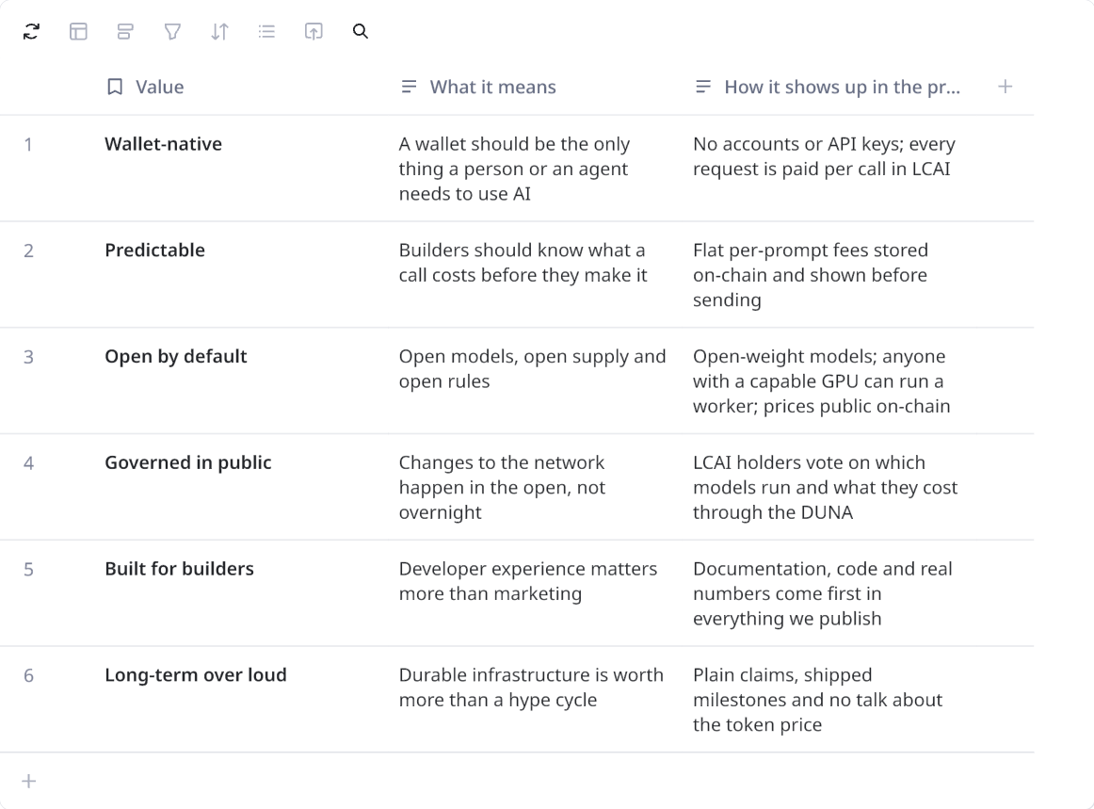

4. Positioning

Positioning statement
For developers building AI agents and on-chain applications, Lightchain is the inference layer agents can pay for. Any agent can call open AI models from its own wallet at one flat price per prompt, set on-chain and known before the request is sent, with every job paid and settled on Lightchain's own chain. Per-token APIs ask for accounts, keys and credit cards and send the bill afterwards; Lightchain lets software buy intelligence the way it already moves money, call by call and on-chain, with the cost decided in advance and governed in public.

Category
Decentralized inference network. Lightchain is an EVM-compatible, AI-native Layer 1 on which inference requests are native transactions. Independent workers run open models on their own GPUs, stake LCAI to take part, and earn a fee for every job they complete. The network is moving from dispatcher-routed jobs to workers claiming jobs directly on-chain.

How it works
- An agent, app or person sends a prompt from a wallet. The fee for the chosen model is fixed on-chain, so the cost is known before anything is sent.
- The fee is held on-chain while a worker takes the job. Workers are independent GPU operators who have staked LCAI to join the network.
- The worker runs the open model and streams the answer back. The prompt is encrypted on its way to the worker, and long answers cost the same as short ones, up to each model's output limit.
- The job settles on Lightchain and the worker is paid. Every step happens on Lightchain's own chain rather than in a private billing system.

Audiences
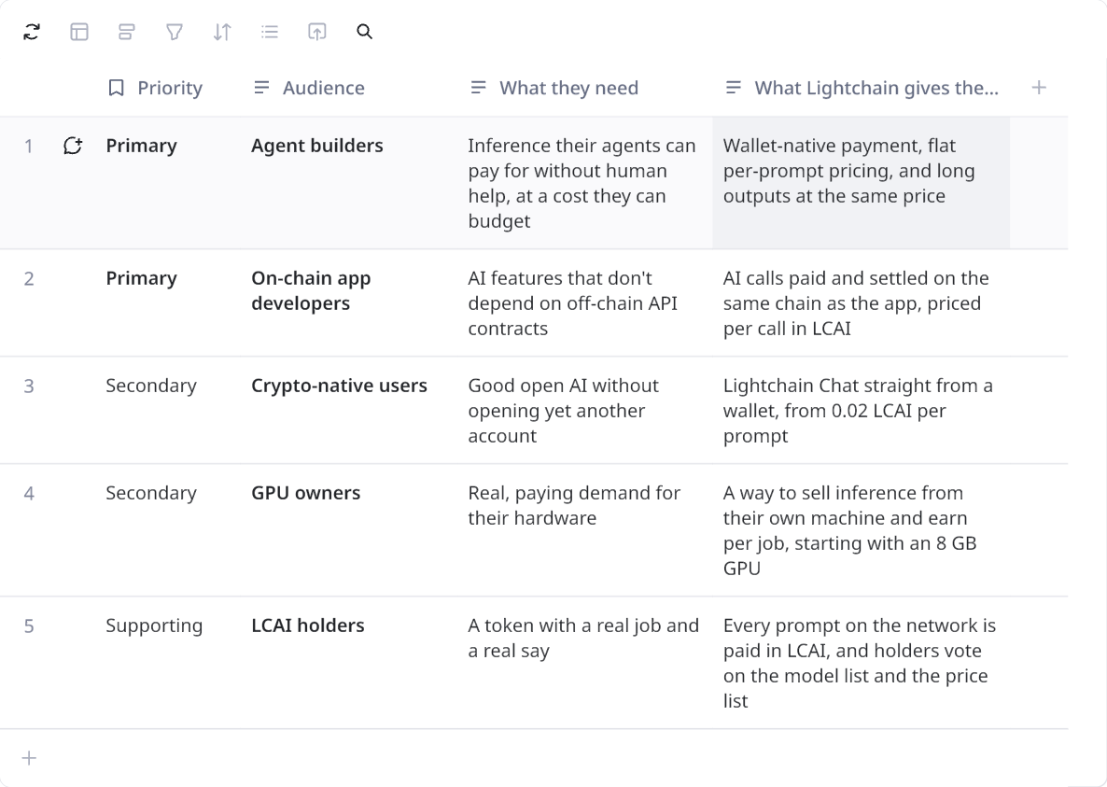

Competitive frame
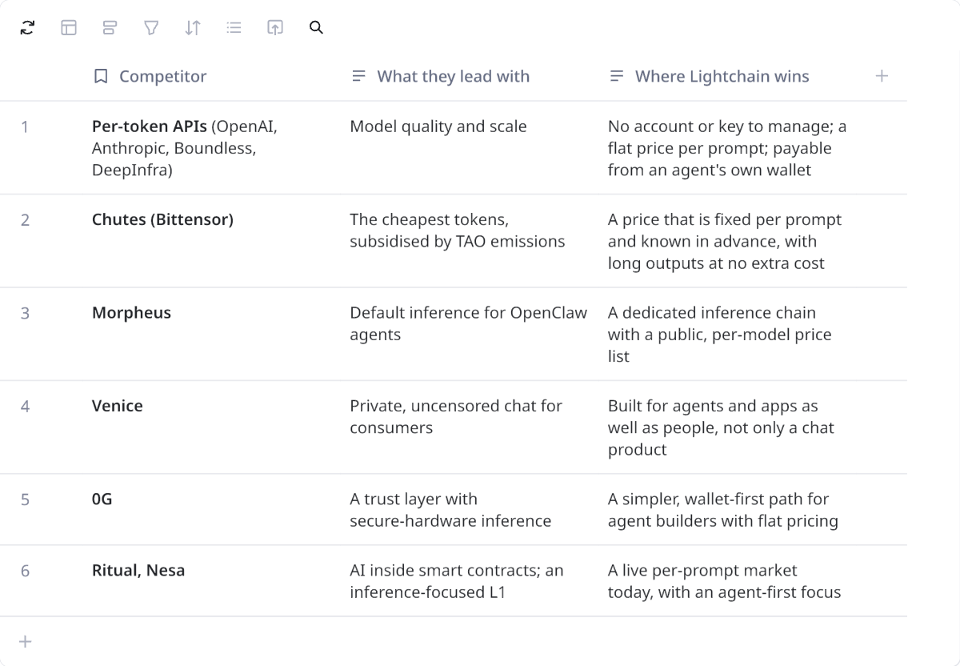

The space Lightchain owns: inference designed around how agents actually pay, wallet-native, per call and priced in advance, on open infrastructure with a price list decided in public.

5. Messaging framework

The five pillars
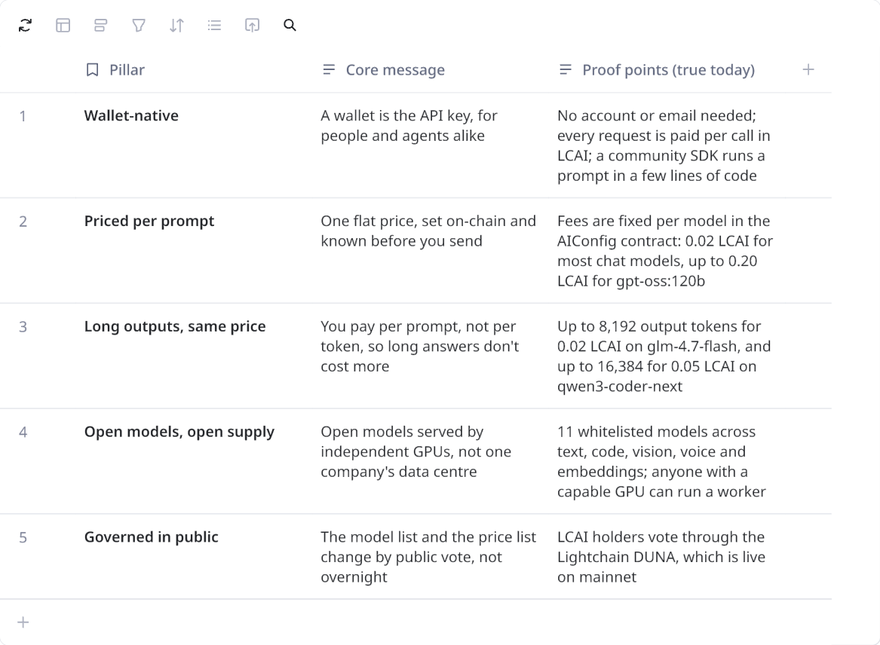

Messaging angles
- "Get fuel for always-on agents." The lead story.
- "Know the price before you prompt." Per-token billing means you only learn the cost afterwards. On Lightchain the fee is fixed per model and visible before the request is sent. Use for: developer content, comparisons and paid amplification.
- "Long answers, same price." The economics of long outputs, where per-prompt pricing pulls furthest ahead of per-token pricing for coding and research agents. Use for: benchmarks and developer outreach.
- "Inference as a transaction." On Lightchain, an AI request is paid and settled like any other on-chain transaction, which makes it natural to build into agents and apps. Use for: developer docs, hackathons and bounty calls.
- "A wallet is your API key." The simplest way to explain access: no sign-up, no key rotation, no billing dashboard. Use for: onboarding content and short videos.
- "Open models, live on-chain." Model launches and the growing model menu, each with its price and limits. Use for: model spotlights and release posts.
- "A price list decided in public." Fees and models change through public votes by LCAI holders rather than overnight announcements, which gives builders stability. Use for: governance recaps and enterprise-curious builders.
- "Powered by the GPUs next door." The network is supplied by independent operators on their own hardware, and anyone with a capable GPU can sell inference into it. Use for: worker recruitment and supply-side stories.

Messages by audience
Agent builders
- Headline: The inference layer agents can pay for.
- Support: Give your agent a wallet and it can call open models on its own, at one flat price per prompt that it knows before it sends, so its running costs are predictable however long its answers get.
- Call to action: Start building.
On-chain app developers
- Headline: Inference as a transaction.
- Support: Add AI features to your app and pay for every call on the same chain, without API contracts, keys or minimum spends.
- Call to action: Read the docs.
Crypto-native users
- Headline: Open AI, straight from your wallet.
- Support: Chat with open AI models without opening an account, from 0.02 LCAI per prompt.
- Call to action: Try Lightchain Chat.
GPU owners
- Headline: Sell inference from your GPU.
- Support: Serve open models to agents and apps from your own hardware and earn LCAI for every job you complete. An 8 GB GPU is enough to start with the smaller models.
- Call to action: Become a worker.
LCAI holders
- Headline: Every prompt runs on LCAI.
- Support: Every request on the network is paid in LCAI, and holders decide through the DUNA which models the network runs and what each one costs.
- Call to action: Vote on the DAO.

6. Bios, banners and profile copy

X (Twitter)

Bio (under 160 characters)
The inference layer agents can pay for.
Alt add: Open models at one flat price per prompt, paid from any wallet and settled on-chain.

Alternative bios
Open AI models for agents and apps, at one flat price per prompt, paid from any wallet and settled on Lightchain.

7. Tone of voice
It is direct and specific, confident about what works today, honest about what is still in development, and never reaches for hype when a number or an example will do.

Principles
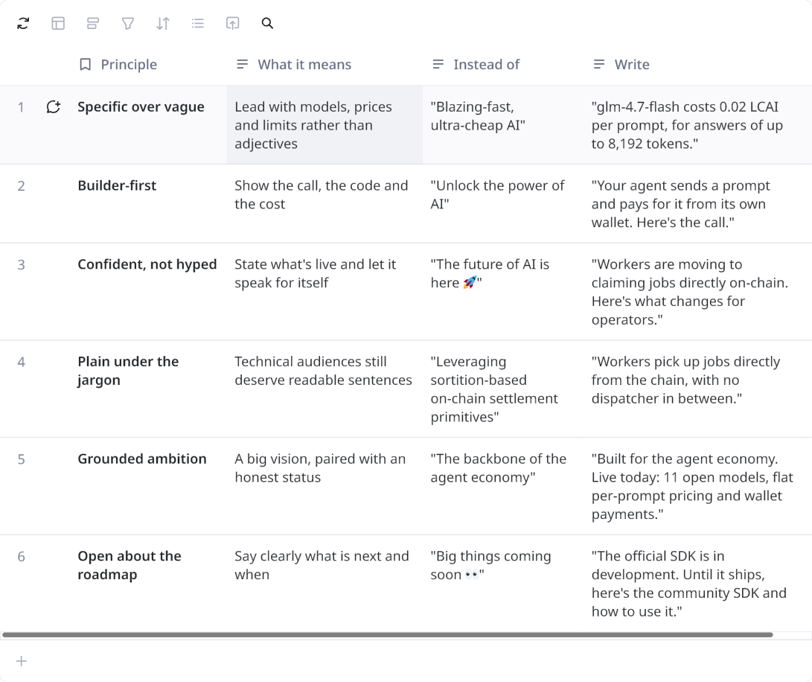

Style rules
- Write in full, connected sentences. Use short lines for emphasis only, not as a default rhythm.
- Use sentence case for headlines and buttons, and active voice throughout.
- Avoid any hashtags, emojis or hyped jargons.
- Label anything that isn't live as Testing, In development or Proposed.
- In developer content, prefer code snippets, screenshots and real numbers to illustrations.

Word list
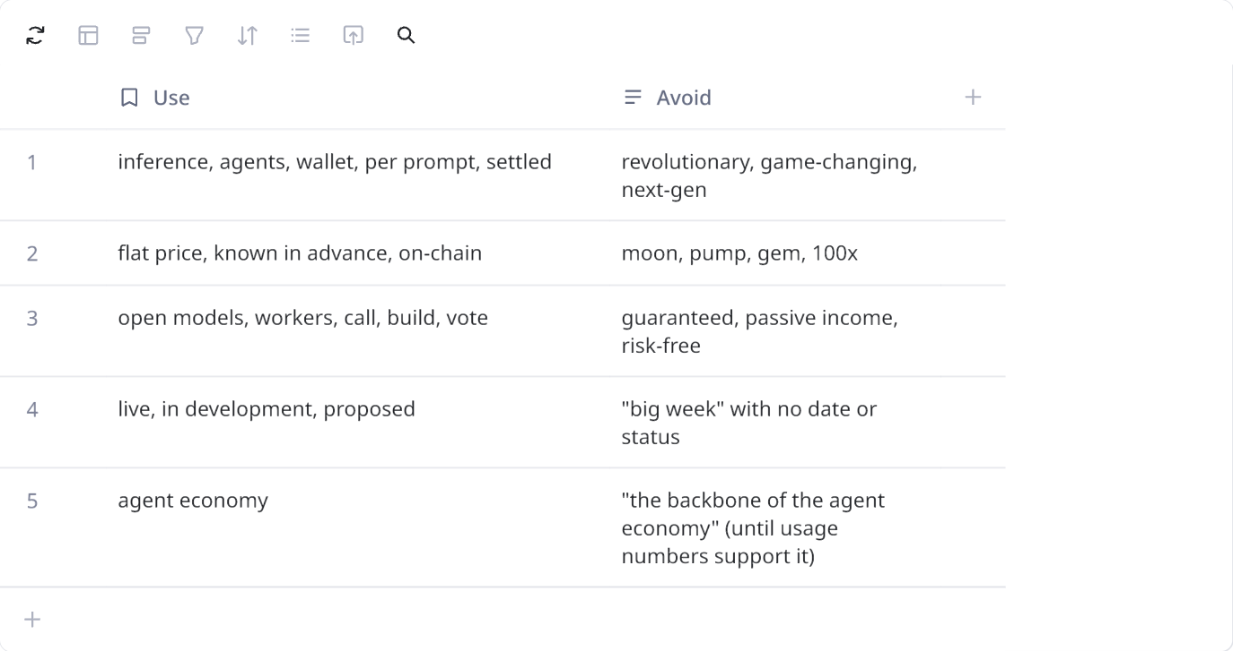

8. Content pillars
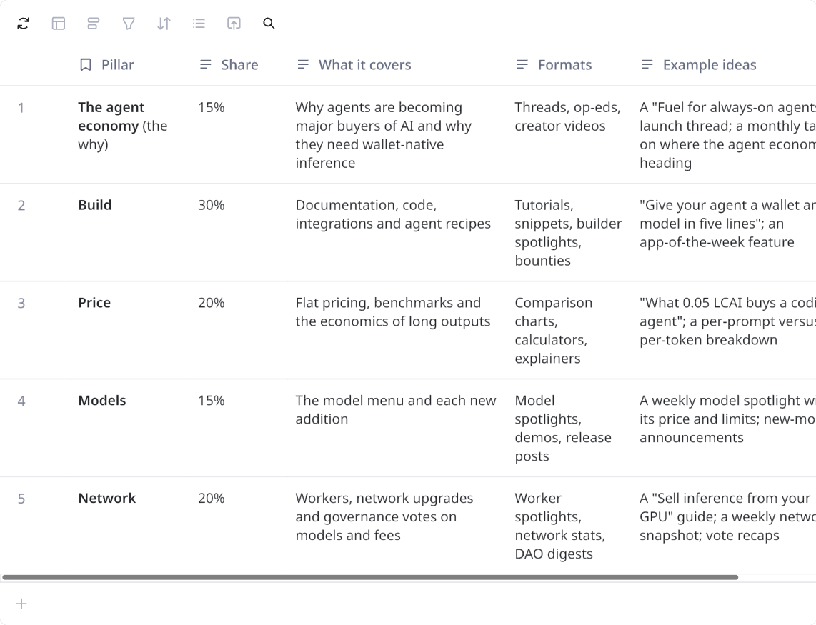

9. Proof points and guardrails

Proof points we can use today
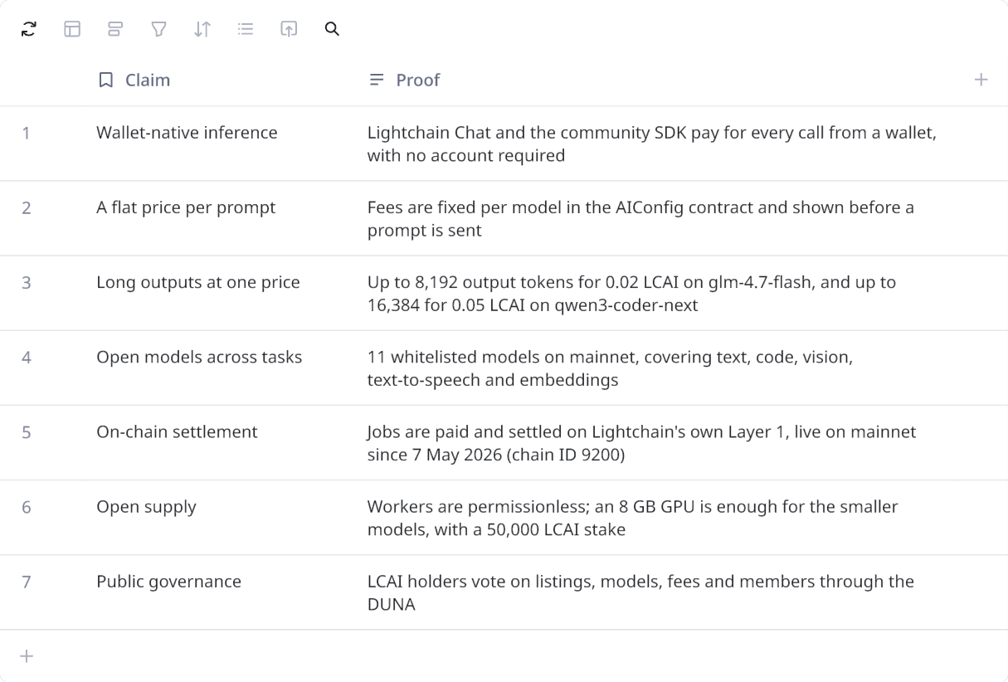

10. Open items for the Lightchain team
- Approval of the positioning line "The inference layer agents can pay for" and the tagline "Fuel for always-on agents".
- Official SDK and API: a confirmed release date, since agent builders need a first-party path before we push them hard.
- OpenClaw provider plugin: whether the team can build or sponsor one, as this is where agent builders already choose their providers.
- Stable pricing: whether fees can be pegged to USD while still being paid in LCAI, so agents can budget reliably.
- Payment options: any plans to accept stablecoins alongside LCAI.
- Model roadmap: which newer open models are next, and how quickly new ones can be whitelisted.
- Usage data: jobs per day, active workers and typical latency, so we can publish real network numbers.
- Free starter credits: a small allowance so developers can test the network before buying LCAI.
- Worker economics: whether per-job fees cover worker costs at current prices, so we can describe earnings fairly.
- On-chain job claiming: confirmation that the switch to dispatcher-free mode is complete on mainnet.
- Website copy: the route for submitting the hero and copy suggestions to the DUNA
